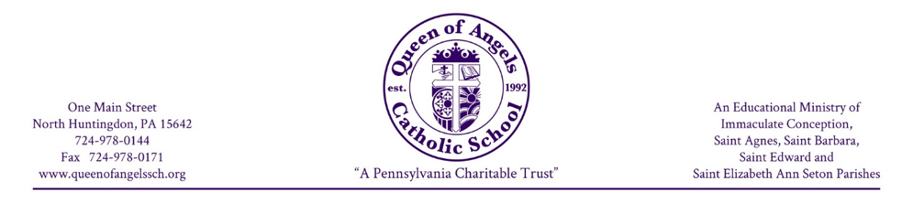

August, 2026

Dear Parents:
Federal programs provide essential services to students in non-public schools. Your federal tax dollars can be used by non-public schools to provide materials, services and programming. To receive the maximum amount of tax dollars for Queen of Angels Catholic School it is essential that you complete and return the enclosed survey. The return of these surveys is required before these critical funds can be awarded.
I want to assure you that all information will be kept confidential. Only total numbers that represent the whole school are communicated to the federal programs.
Please return the form as soon as possible. The deadline is August 28, 2026. Do not hesitate to call me if you have any questions about the survey.
Thank you for your assistance.
Sincerely,

Jennifer Filak, Principal

FAMILY SURVEY
2026-2027
A) Find your family size and the annual gross income level listed beside it on the chart printed below.
Family Size | Annual Rate
1* | $ 29,526
2 | $ 40,034
3 | $ 50,542
4 | $ 61,050
5 | $ 71,558
6 | $ 82,066
7 | $ 92,574
8 | $ 103,082
For each additional  family member add | +$ 10,508

*This may be a foster child, an emancipated youth, or a special education child over age 18.

Note: If you are paid on a weekly or monthly basis, please multiply that amount into an annual
figure for comparison based on the weeks or months you actually work each year.

Is your annual income equal to or less than this amount? Yes____ No____

Is your family eligible for food stamps? Yes____ No____

B) Are you receiving TANF Cash Assistance? Yes____ No____
(Formerly AFDC or Public Assistance)

C) Are any of your children eligible to receive
medical assistance under the Medicaid program Yes____ No____

D) We have not checked any of the above boxes because
we do not wish to share this information in writing. Yes____ No____

Family Name (print):_________________________________________ # of family members____

Address (home location not mailing):_________________________________________________

Public school district in which you reside: _____________________________________________

List your child(ren)’s name(s), grade level(s), and the public school building(s) the child(ren) would
attend if you had not chosen our school.
_____________________________________________________________________________

_____________________________________________________________________________

Please complete and return by August 28, 2026.

