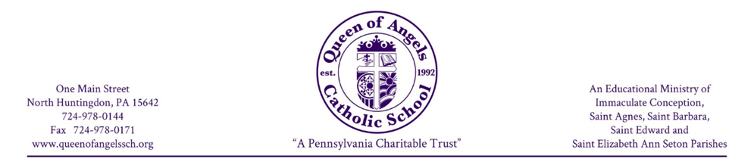

HOME LANGUAGE SURVEY
2026-2027 School Year
Used to determine a primary or home language other than English

Parents or guardians are asked to complete the following questions about the language use of your child. When appropriate, the child may answer the questions.

Student’s Name Date

Date of Birth ___________________________ Age Grade
(MM/DD/YYYY)

Parent/Guardian’s Name (s)

Telephone _______________________ Public School District of Residency
(with Area Code)

Country of Origin

Other countries of residence (please list)

Parents are not required to answer questions with regard to origin. However, even countries of origin whose primary language is English may have a dialect making it difficult for a child to understand American dialects.

- What was the first language your child learned to speak?

English Other:___________________________________________________________

- What language(s) does your child speak most often at home?

English Other:___________________________________________________________

- What language(s) do you use when speaking to your child?

English Other:___________________________________________________________

- What language(s) is spoken most often in your home?

English Other:___________________________________________________________

- What language(s) can your child read? (if appropriate to age of child)

English Other:___________________________________________________________

- What language(s) can your child write? (if appropriate to age of child)

English Other:___________________________________________________________

Survey conducted/completed by (print name):
Parent/ Guardian Name (print):
Parent/Guardian Name (Signature): Date

Please complete, sign and return to the office by August 28, 2026.

